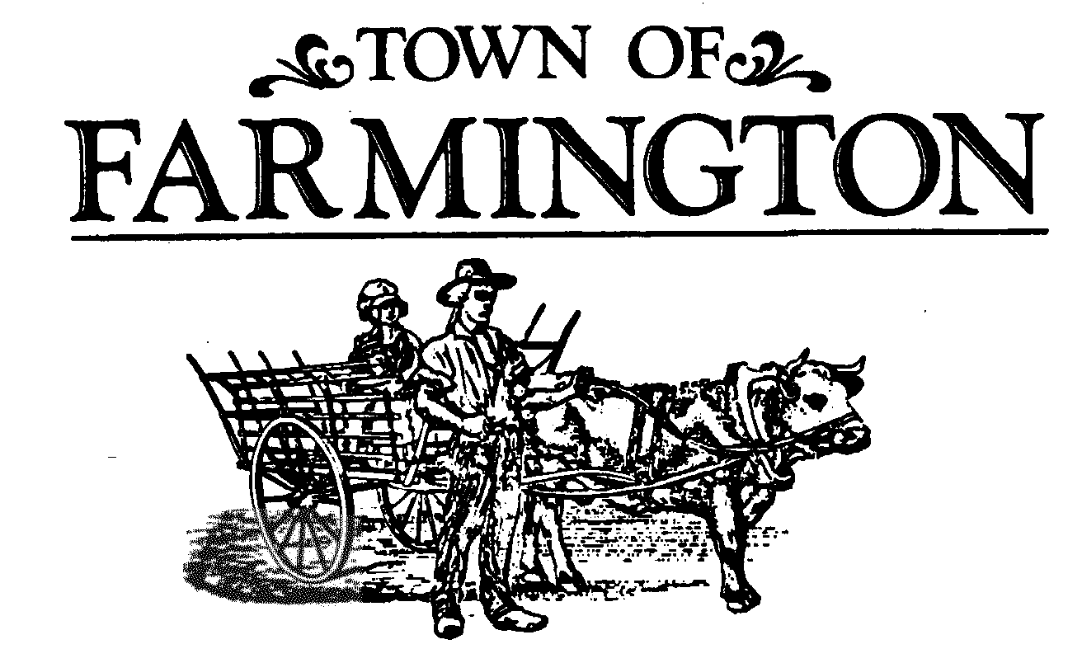
Planning Board Meeting Agenda
March 20, 2024 Meeting
7:00 p.m.

THIS MEETING WILL BE HELD IN THE MAIN MEETING ROOM, AT THE TOWN HALL, 1000 COUNTY ROAD 8, FARMINGTON, NEW YORK 14425. THOSE NOT WISHING TO ATTEND MAY PARTICIPATE VIRTUALLY IN THE MEETING BEING CONDUCTED SIMULTANEOUSLY AT THAT TIME ON-LINE, OR OVER THE PHONE.
Join the meeting by clicking the following link:
https://zoom.us/j/93105325588?pwd=aGlsSkVySklVdTVldnBtWjNJbnlhZz09
Meeting ID: 931 0532 5588
Passcode: 356169
One tap mobile
+16465588656,,93105325588#,,,,*356169# US (New York)
Dial by your location
+1 646 558 8656 US (New York)
Find your local number: https://zoom.us/u/adnn0foxAt

1. OPEN MEETING

2. APPROVAL OF MEETING MINUTES

3. LEGAL NOTICE PUBLISHED

4. ORDER OF BUSINESS

CONTINUED SITE PLAN AMENDMENT:

PB 0507-21 FINAL SITE PLAN AMENDMENT
NAME: UNION CROSSING DEVELOPMENT, LLC, 105 DESPATCH DRIVE SUITE A, EAST ROCHESTER, NEW YORK 14445
LOCATION: THE PROPERTY IS LOCATED ON LAND AT THE NORTHWEST CORNER OF THE INTERSECTION OF COUNTY ROAD 41 AND COUNTY ROAD 8
ZONING DISTRICT: LI Limited Industrial
REQUEST: Final Site Plan Amendment to increase the building size for the western building to provide a 200,000 square-foot building with a future building expansion area of 100,000 square-feet for a total building square-footage of 300,000 square feet and to decrease the eastern building size to 132,000 square-feet with the total building area of both buildings to remain 432,000 square feet.
Town of Farmington Planning Board
March 20, 2024
Page 2 of 2

5. OTHER BOARD ACTIONS:

- Final LOC Release – Swetman Property
- Final LOC Release – Home Power Systems

DISCUSSION

6. OPEN DISCUSSION

Reports: Director of Development
Code Enforcement Officer
Town Highway/Parks Superintendent
Town Engineer
Conservation Board
Fire Department
Chairman of Planning Board

7. PUBLIC COMMENTS

8. ADJOURNMENT OF MEETING

Next Meeting Date: April 3, 2024

