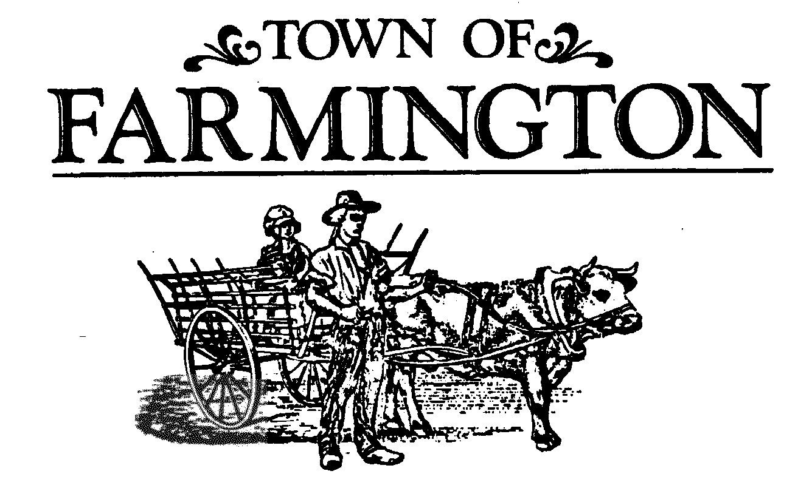

***Planning Board Meeting Agenda***

**July 2, 2025,**

**Meeting 7:00 p.m.**

**THIS MEETING WILL BE HELD IN THE MAIN MEETING ROOM, AT THE TOWN HALL, 1000 COUNTY ROAD 8, FARMINGTON, NEW YORK 14425. THOSE NOT WISHING TO ATTEND MAY PARTICIPATE VIRTUALLY IN THE MEETING BEING CONDUCTED SIMULTANEOUSLY AT THAT TIME ON-LINE, OR OVER THE PHONE. Join the meeting by clicking the following link:**

<https://zoom.us/j/93105325588?pwd=aGlsSkVySklVdTVldnBtWjNJbnlhZz09>

Meeting ID: 931 0532 5588

Passcode: 356169

One tap mobile

+16465588656,,93105325588#,,,,*356169# US (New York)

Dial by your location

+1 646 558 8656 US (New York)

Find your local number: <https://zoom.us/u/adnn0foxAt>

1. **OPEN MEETING** – Chairperson introduces members and Town staff present, identifies the emergency exits and informs that this meeting is to be conducted in accordance with the adopted 2025 Planning Board Rules of Procedure.

2. **APPROVAL OF** – **June 18, 2025, MEETING MINUTES.**

3. **LEGAL NOTICES PUBLISHED (0)** – Chairperson attests to no legal notices being published for tonight’s meeting.

4. **ORDER OF BUSINESS** -

1. **CONTINUED PUBLIC HEARINGS (0):**
2. **NEW PUBLIC HEARINGS (0):**
3. **PUBLIC MEETING ACTION ITEMS (3):**

### 1. PB #2025-0601 Georgiana Gerlock, 4941 Shortsville Road, Shortsville, N.Y. 14548.

### Final Two-Lot Subdivision Plat, Lots #1 and #2, Gerlock Subdivision Tract, located along the east side of Sand Hill Road, between Shortsville Road and Latting Road.

2. **PB #2025-0602 Ryan J. and Ashley E. Braeger, 2465 State Route 21, Palmyra, N.Y. 14522.**

**Final Site Plan, Tax Map Account 10.00-1-29.111, a proposed single- family dwelling and a freestanding two car garage with related site improvements to be located on a parcel of land along the south side of Turner Road, between Ellsworth Road and Yellow Mills Road.**

3. **PB#2025-0603 Nick Lowry & Phyllis Caves, 4341 Cream Ridge Road, Macedon, N.Y. 14502.**

**Preliminary Site Plan Application, Lot #2 Lowry Subdivision, single- family dwelling and related site improvements to be located along the west side of Ellsworth Road. Findings and determination whether to accept the application for scheduling a public meeting.**

### 5. OTHER BOARD ACTIONS (2):

1. **Partial Letter of Credit Release, Release #2, Creekwood Townhouse Project – Phase 2.**

**b.** **Continued discussion upon proposed text amendments to Chapter 144, Land Subdivision, Town Code of the Town of Farmington.**

6. **OPEN DISCUSSIONS:**

**Reports:** Director of Development

Code Enforcement Officer

Code Enforcement/Zoning Officer

Town Highway/Parks Superintendent

Town Engineer

Environmental Conservation Board

Farmington Fire Department

Planning Board Members

Planning Board Chairperson

7. **PUBLIC COMMENTS:**

8. **ADJOURNMENT OF MEETING**

**Next Meeting Date: Wednesday, July 16, 2025.**